**What you will need for registration:**

**Youth**

1. Age on 1/1/2025 and age on 6/18/2025
2. Dietary/Disability/Special needs information
3. Adult T-Shirt Size
4. Youth’s cell number while at event
5. Did Youth apply and participate in the 4-H State Awards Program?
6. Would they be interested in applying for the MSU Pre-College Scholarship in eligible?
7. Are they going to be arriving early? (This must be coordinated and approved by county staff prior to registration)
8. What track and sessions are they registering for? (Fill out the sheet in session description booklet)
9. Did you receive a coupon code from your county office?

Adult

1. Dietary/Disability/Special needs information
2. Adult T-Shirt size
3. How many nights are you registering for?
4. Did you receive a coupon code from your county office?

USE FIREFOX OR CHROME TO REGISTER

County means what county they are housing with

Tip Sheet

**Family Account**

The first thing you are going to want to do is create a Family Account. Within that Family Account, you can register all the Youth and Adults in your family/household that will be attending 4-H Exploration Days Wednesday, June 18 through Friday, June 20, 2025.

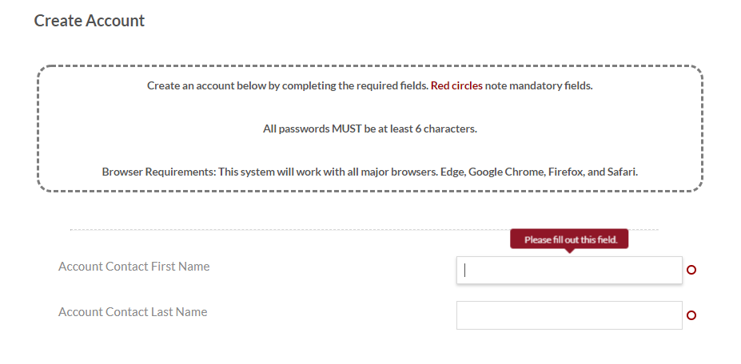

Your information will be pre-populated into the next page (this page looks similar to the one before, but there will be a second set of boxes to fill in with address and phone number for the Family Account.)

The next page is where you will register the youth in your family/household.

**Returning Families:**

Returning families registering need to use the same e-mail and password as last year/previous years. They will log in using the Login button at the top. Password resetting cannot be done in advance so families will need to do this the night of (it is a quick “forgot password” choice, then enter e-mail address, a code will get sent to the e-mail to confirm, and then a new password can be set up).

Families can ask their 4-H PC to look up what e-mail that families used when registering by looking in the Account Owner information tab.

The system will also acknowledge if an e-mail already has an account in the system.

**Youth registration**

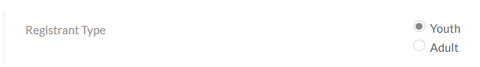

Continue filling in the information on this page as it pertains to your youth.

**Special dietary, Disability Needs and Support**: If you choose yes, it will open text boxes for additional information and/or additional questions regarding that choice.

**Registration Selection**

On this page, you will select “4-H Exploration Days Youth Participant”.

* If you’ve already made arrangements and received approval from your county staff, you can select “Early Arrival for Youth Participant” also.

When selecting your sessions, you will click the box next to your first session block and choose the session title you want from the list that pops up. You will then go back up and select the next session block and session title until you have all your selections marked. Please be aware that the selections will be either Session A, Session B and Session D; **OR** Session C and Session D. Please the session breakdown below:

* C3 Career Tracks T) Wednesday, June 18- * 2:30 pm- 4:30 pm
* Session A) Thursday, June 19 8:30am -11:30am **\*Must also choose a Session B option\***
* Session B) Thursday, June 19 1:30pm-4:30pm **\*Must also choose a Session A option\***
* Session C) Thursday, June 19 8:30am-11:30am **AND** 1:30pm-4:30pm **\*please note the break in-between\***
* Session D) Friday, June 20 8:30am-11am

Waiting list will not be available for sessions. If you don’t get into the your first session, please pick a different session to take.

**Coupon Code**: This is important! If you have received a coupon code from your county 4-H staff make sure you enter it exactly how it is given. This is case sensitive!!

**Parent/Guardian Information**

Fill in at least one parent/guardian.

**Emergency Contact Information**

Please list additional emergency contacts, beyond the parents/guardians listed earlier, who may be contacted if there is an emergency during the event. Fill in at lease one emergency contact.

**Confirm Selection**

On this page you will see everything you selected for your youth within the Registration Selection page. Please double check your options and make sure that everything looks correct.

**Payment Options**

On this page, you will see what is due for this youth based on the selections made in previous pages.

You must choose whether you are paying the balance in full or if you are only paying the $50 deposit at this time and will be paying the remainder of your balance at a later time or are receiving a local scholarship/grant. All balances must be paid by May 26th or registration will be canceled.

Click the Add Plan button for the option you are selecting.

**PLEASE NOTE:** If you know you will be receiving other scholarships or funds are being covered in other ways**, DO NOT PAY IN FULL!!** Deposit of $50 should be paid and credits will be applied on the back end of your registration for local scholarships you might receive. MSU will not provide refunds for money paid that is being paid through scholarships.

For more information on fee schedule and refunds, please go to: <https://www.canr.msu.edu/4_h_exploration_days/registration_information>

You will then see a pop-up box that asks if you would like to add another attendee. Please register all youth first before registering adults. You can either click “No, I am done” on the left, or “Yes! Add another attendee” on the right.

If you are done registering for your family, please skip down to ***

**Adult Registration**

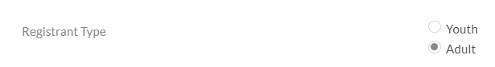

Be patient for the processing page. It may take a few minutes for the payment to process.

When the page, says “Thank you for your payment” you must hit the Submit button on the bottom right of the page. You want to make sure that your progress for registration ends at 100% completion (noted in the My Progress bar at the top of the screen.)

Participants should receive an e-mail once their registration has gone through and we received payment.